## Target Market

Figure 2-1 illustrates in particular how the application should be designed and what values the components should have:

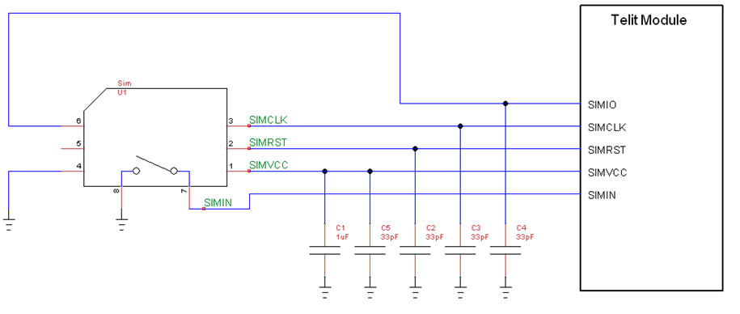

Figure 2‑1 SIM connection